**Our Energy Future**

**Photovoltaic and Photothermal Energy Production**

Although the subsistence level of continuous energy use is roughly 100W, those in the US consume around 10,000W, with 15% of that being in the form of electricity usage.

One of the most compelling reasons to increase solar adoption is because there is so much solar power available – somewhere between 85,000 and 120,000 TW of energy is continuously being absorbed by the Earth’s atmosphere. Contrast that figure with the 15-18 TW of current world energy capacity, or the 70 TW that would theoretically be needed if the entire world used energy at the same rate as the US and Canada.

There are two broad classifications of solar technologies that translate energy from the sun into energy humans can use.

* Low temperature solar water heaters (SWH)

Around since the 19th century this technology heats water using the energy from the sun

* Solar energy generation systems (photons to electrons)

This is the type of energy most people think of when using the term “solar energy.” There are different types of systems which convert the photons from sunlight into electrons used for direct current (DC) electricity:

1. Direct conversion to electricity through photovoltaic (PV) or concentrated photovoltaic (CPV)
2. Solar-Thermal Power

Using mirrors to concentrate the sun’s energy into a specific point which drives traditional steam turbines and/or engines that create electricity

1. Other technologies (solar Stirling engines)

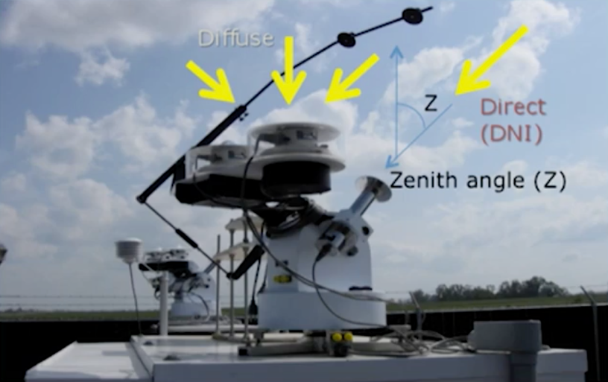The reason why various technologies are used is because of the differences in microclimates where solar power is harnessed, and differences in scale where the power needed varies drastically depending on the use case (e.g., power plant needs to produce power on a much larger scale than for your solar-powered watch).

Different solar technologies use different components of the *solar* *irradiance*, which is the amount of electromagnetic radiation received from the sun. There are a few types of solar irradiance:

*Direct Normal Irradiance* (DNI) is the energy received directly from the sun’s beams, and is captured by an instrument that looks similar to a paper towel tube which follows the path of the sun (called the *zenith angle*) throughout the day.

Contrast this with the energy from sunlight that gets scattered by the atmosphere, called *diffuse horizontal irradiance* (DHI). Without the atmosphere, there would be almost no diffuse irradiance.

Combining the diffuse horizontal irradiance, the direct normal irradiance, and the zenith angle of the sun at any given point in the day, you get the total amount of irradiance available, aka the *global horizontal irradiance* (GHI)

$$GHI=DHI+(DNI × \cos{z})$$

It is important to note that different solar technologies use different parts of the solar irradiance.

*Photovoltaic (PV) cells*

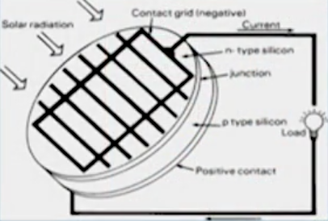The most common way to take the photons from the sun’s rays into electrons needed for electricity is through a photovoltaic cell.

Flat PV arrays – the most common type of photovoltaic arrays which you have seen in farms and/or on portable electronics -- have a fixed angle from which to capture solar energy, and is roughly 20% percent efficient in taking the energy from the sun and converting it into electricity.

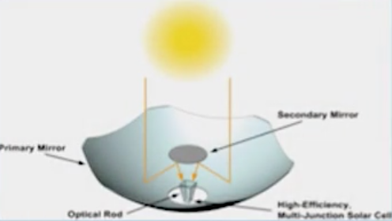Concentrated PV arrays use mirrors to reflect the energy into a concentrated area which contain a *multi-junction solar cell*. A multi-junction solar cell contains multiple positive-negative (p-n) junctions made of different semiconductor materials; these types of cells are much more expensive than flat PV arrays which is why the system was designed to use fewer such cells.

Concentrated photovoltaic array

Flat Photovoltaic cell

A reason why the multi-junction cell is more expensive is because the different junctions within the solar cell absorb different wavelengths, therefore allowing for increased efficiency of the cell as a whole; roughly 40% efficient compared to the ~20% efficiency seen in flat PV arrays. The cost of one multi-junction cell is ~100x that of the flat PV array. An additional note is that the CPV panels rely solely on the DNI as opposed to the DHI.

*Concentrated Solar Power (CSP)*

CSP is a bit different than PV because the power from the sun is used as thermal energy which raises the temperature of water to the point of creating steam. The steam then passes through a turbine connected to a generator which subsequently creates energy.

Diagram of concentrated solar power using parabolic troughs

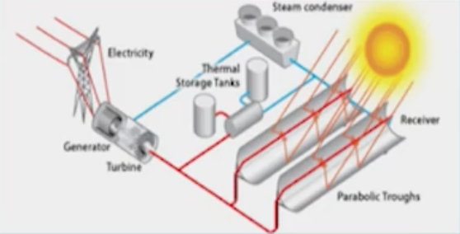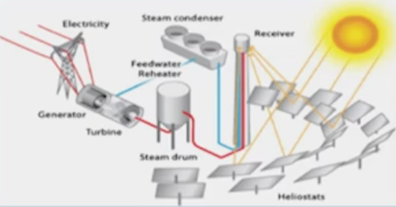

Diagram of Concentrated solar power using heliostats

There are multiple ways to achieve this – two of the more popular ways are through *heliostats* and *parabolic troughs*. The main difference between these two types of CSP is the configuration of the mirrors which reflect the solar power into the receiver which heats the water/steam used to generate the electricity.

CSP is somewhere between 25-35% efficient in harnessing the energy from the sun.

One of the reasons why solar energy isn’t used more broadly is the variability of the amount of energy that is available to be harnessed at any given moment. While we can more or less estimate the amount of solar power available depending on the latitude, time of year and day, there exists a large amount of variability in the amount of energy from day-to-day.

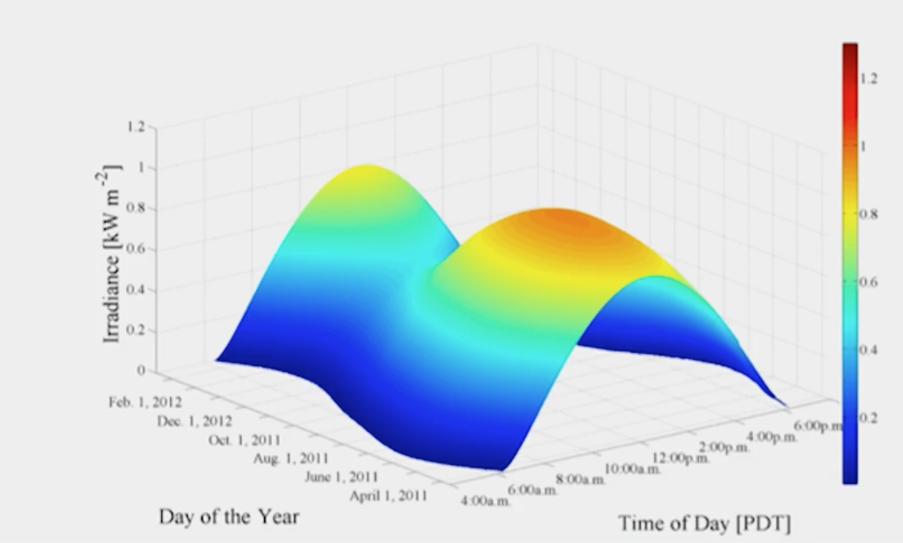Smoothed variability available in a location in California. This is what the data would look like without the presence of the atmosphere

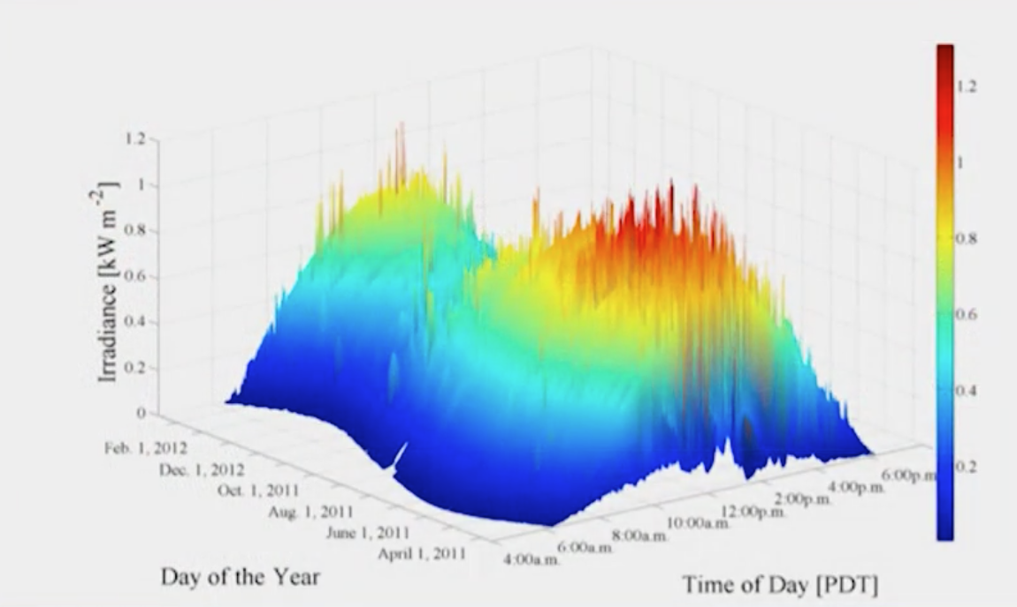

Actual observed data for the same location

Critical barriers to the wider adoption of solar power include:

* Achieving *grid parity* where the cost of solar is the same or below the cost of conventional sources (already a reality in many places)
* Reduce costs to below $1/W – currently between $4-7/W but falling fast
* Efficient overnight/overcast storage systems to overcome low capacity/intermittency issues

By *capacity* issues, that means the percentage of power that *actually* gets produced in comparison to the theoretical maximum a given power plant *could* produce. For example, if a power plant is rated as a 200MW power plant over the course of a year, and that power plant produces 100MW, its capacity factor is 50%.

Because solar is intermittent, that impacts its capacity factor because the power plant might not produce power during the nighttime. However, if storage is implemented and/or geothermal power is produced in conjunction with the solar power during the day, this could increase a renewable power plant’s capacity factor.

* Variability smoothers to improve energy quality got integrating into the grid (short-term forecasting and storage)

The reason why storage is an issue with solar is because electrons are much more difficult to store than say, thermal energy. This is why solar/geothermal combinations are attractive, because the solar energy could be converted to thermal energy and thus more easily be stored.

A reason why integration into the grid is difficult is because it was designed to have a fairly steady state of power generation (and enable more variation in demand). This worked fine in the time when fossil fuels produced much of the energy, but with variable renewable sources entering the mix, the grid needs to become “smarter” to handle that variation. Without any drastic changes to the existing grid, it tends to handle ~20-30% renewables incorporated into its power generation. With distributed generation, where consumers are producing power that could be incorporated into the grid, this issue is exacerbated.

However, in addition to the pure amount of solar energy available, a big factor in encouraging the usage of solar is the fact we are diurnal animals that use more energy in rhythms similar to that of the sun.

